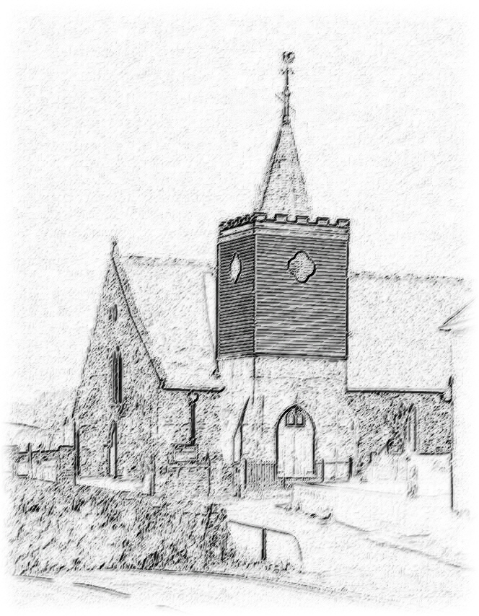
Mrs V. Taylor
Clerk & Registrar of Burials
Tel: 01983 85852576
3 Downside
Ventnor
Isle of Wight
PO38 1AL

CALBOURNE PARISH COUNCIL

NOTICE OF INTERMENT

Particulars of Deceased:

- Surname ………………………………………….

- Forename(s) ………………………………………….

- Occupation ………………………………………….

- Age ………………………………………….

- Late address ………………………………………….

- Date of Death ………………………………………….

- Place of Death ………………………………………….

Burial Details:

- Day and Date of Burial ………………………………………….

- Time of Burial ………………………………………….

- Officiating Minister ………………………………………….

- Depth of Grave ………………………………………….

- No. of Grave Space ………………………………………….

- Purchaser of grave space ………………………………………….

- Name and Address of Funeral Director:

………………………………………….

………………………………………….

Date of Application: …………… Signature of Applicant: ………………
Please ensure that the relevant Certificate for Burial or Cremation issued by the Registrar for Births and Deaths, or the Coroner’s Order for Burial, is enclosed with this notice.

