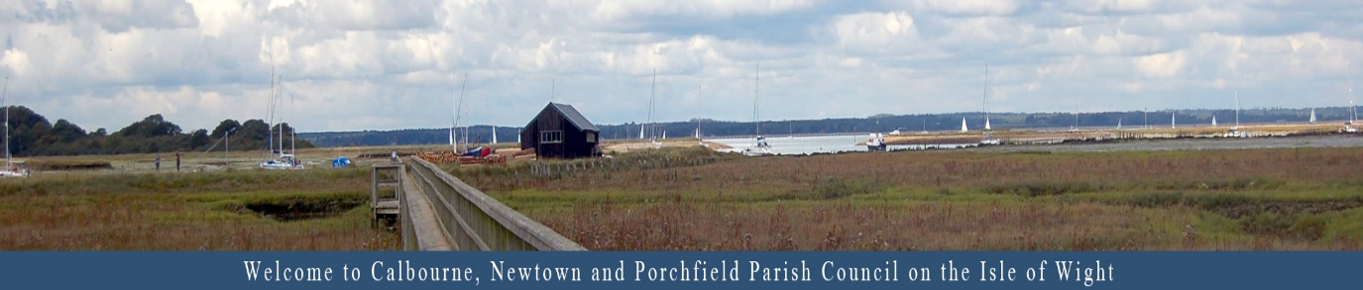
CALBOURNE, NEWTOWN
AND PORCHFIELD PARISH COUNCIL
Housing Needs Survey. Serving the villages of
Calbourne, Newtown and Porchfield

Calbourne Newtown and Porchfield Parish Housing Needs Survey

Conducted by the Parish Council

Introduction

We want to hear from you.

This survey helps our Parish Council understand the housing needs of residents across our parish. Your views will guide future planning and ensure that any housing development reflects the needs and aspirations of our community.

Please return this survey by [insert deadline] in the prepaid envelope that is with this survey

All responses are completely confidential and used by our Council solely for planning purposes.

Section 1: About You

- Which village do you live in?
☐ Calbourne ☐ Newtown ☐ Porchfield
☐ Other:

- How long have you lived in the parish?
☐ Less than 1 year ☐ 1–5 years ☐ 6–10 years  ☐ Over 10 ☐ Don’t currently live on Parish  3. What is your age group? | 1 | ☐ don’t currently live in the parish
☐ Under 16 ☐ 16–24 ☐ 25–44 ☐ 45–64 ☐ 65+

- What is your current housing situation?
☐ Homeowner (owned outright) ☐ Homeowner (with mortgage)
☐ Private rented ☐ Housing association / social housing
☐ Living with family/friends ☐ Temporary accommodation
☐ Other:
Your Household

- How many people live in your household?
☐ 1 ☐ 2 ☐ 3–4 ☐ 5 or more

- Do you expect your household size to change in the next 5 years?
☐ Yes ☐ No
If yes, please explain:

- Do any members of your household have specific housing needs (e.g. accessibility, supported living)?
☐ Yes ☐ No If yes, please describe:

Section 3: Housing Needs

- Do you or anyone in your household need to move within the parish in the next 5 years?
☐ Yes ☐ No
If yes, what type of housing is needed? (tick all that apply)
☐ Affordable housing ☐ Smaller home ☐ Larger home
☐ Supported/specialist housing ☐ Retirement/sheltered housing
☐ Shared ownership ☐ Private rental ☐ Self-build plot ☐ Other:

- What are the main reasons for needing to move?
☐ To live independently ☐ To be closer to family
☐ Change in employment
☐ Downsizing ☐ Upsizing ☐ Health/mobility needs
☐ Financial reasons ☐ Other:

- Would you prefer to stay within your current village
or move elsewhere within the parish?
☐ Stay in current village ☐ Move elsewhere in parish
☐ No preference

Section 4: Views on Future Housing

- Do you think there is a need for more housing in the parish?
☐ Yes ☐ No ☐ Not sure
If yes, what types of housing should be prioritised? (tick all that apply)
☐ Affordable homes for local families ☐ Starter homes for young people
☐ Homes for older residents ☐ Rental properties
☐ Eco-friendly/sustainable housing ☐ Self-build
opportunities
☐ Other:

- What concerns do you have about new housing development in the parish?
☐ Impact on local character ☐ Pressure on infrastructure ☐ Environmental impact ☐ Loss of green space ☐ Lack of affordability ☐ Other:

- What benefits do you see in new housing development?
☐ Supporting local families ☐ Revitalising village life
☐ Boosting local economy ☐ Improving housing choice
☐ Other: ___________

Section 5: Final Thoughts

14. Do you have any additional comments or suggestions about housing in Calbourne Parish?

Stay Informed (Optional)

If you’d like to be kept informed about the results or future consultations, please leave your contact details below:

Name: Email

=

