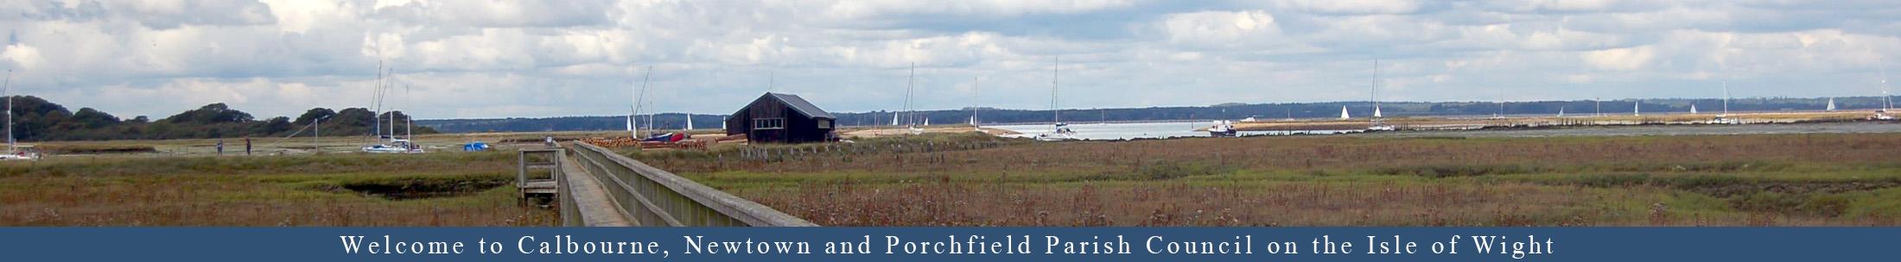

CALBOURNE NEWTOWN AND PORCHFIELD PARISH COUNCIL

NOTICE OF VACANCY IN OFFICE OF PARISH COUNCILLOR
Published: 18TH April 2024

NOTICE IS HEREBY GIVEN
under Section 87(2) of the Local Government Act 1972
that a casual vacancy exists in the office of councillor for
Calbourne Newtown and Porchfield
in the Porchfield Ward

A By-election to fill the vacancy will be held if, within 14 working days from the date of this notice, 10 electors registered in the Ward give notice in writing to the Returning Officer, Electoral Services Office, Isle of Wight Council, County Hall, High Street, Newport, Isle of Wight, PO30 1DU of a request for an election to fill the vacancy.
If no such notice is given by Wednesday 10th May 2024 the Parish Council will fill the post by co-option.

DATED this 19th April 2024

(Signed) Valerie Taylor
Calbourne, Newtown and Porchfield Parish Clerk

