REGISTER OF INTERESTS
CAI-BOURNE NEWTOWN AND PORCHFIELD PARISH COUNCIL
The Calbourne Parish Council requires all Members to complete this register within 28 days of their election. If your circumstances change you are required, within 28 days of the change, to submit written notification of the change to the Monitoring Officer.
MAY 2023
c)
Name of Member...
I set out below my interests and those I am aware of relating to my spouse/partner under the various headings.
Disclosable Pecuniary Interests:
These are interests that are required to be declared by the Localism Act 2011 and the These declarations relate to vou AND any interests you are aware of relating to your spouse or civil partner or a person you live with as husband and wife or as if you were civil artners
Please put "None" where appropriate.
Category of Interest | Your Interests | Interests of your s ouse/ artner
Employment, office, trade, profession or vocation carried on for profit or gain.  This includes any firm or company in which you or your spouse or your partner are a business partner or director. | 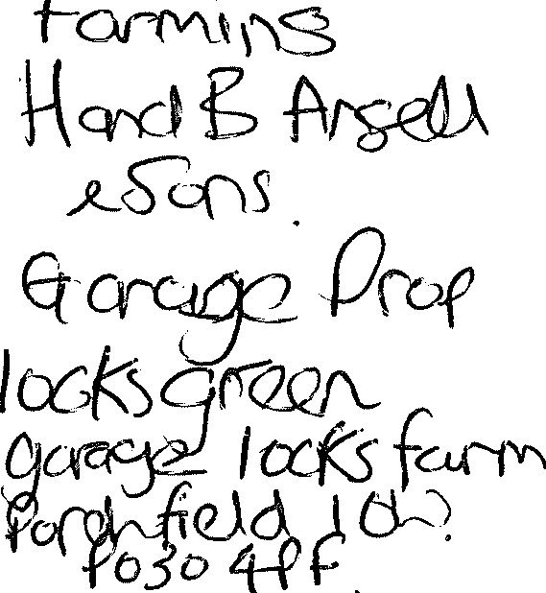 | Schoo(
Sponsorship  Any payment or provision of any other financial benefit (other than from the Isle of Wight Council) made or provided in respect of any expenses incurred by you or your spouse or partner in carrying out duties as a member, or towards the election expenses of you or your spouse or partner. This includes any payment or financial benefit from a trade union within the meaning of the Trade Union and Labour Relations Consolidation Act 1992. | 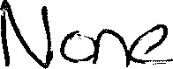 | 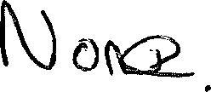

Category of Interest | Your Interests |  | Interests of your s ouse/ artner
Contracts  Any contract which is made between the Isle of Wight Council and either:  - you; your spouse; or your partner; or  - firm in which either you or your spouse or partner is a business partner; or  - a body corporate of which you or your spouse or partner is a director; or  - a body in which you or your spouse or partner has a beneficial interest (that is a firm in which you or your spouse/partner is a business partner or a corporate body in which you or your spouse/partner is a director or an industrial and prudent society where you or your spouse or partner are a member of the management committee or a corporate body in which you or your spouse/partner have a beneficial interest in its securities  - under which goods or services are to be provided or works are to be executed; and  - which has not been fully dischar ed. | 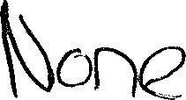 |  | 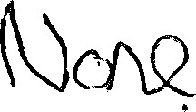
Land  Any beneficial interest in land which is within the Isle of Wight, excluding an easement, servitude, interest or right in or over land which does not carry with it a right for you or your spouse or partner alone or jointly with another to occupy the land or to receive income.  Please give address or description sufficient to identify the location. | 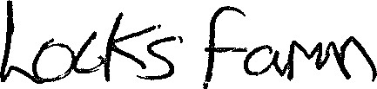 |  | 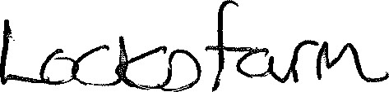
Licences  Any licence (alone or jointly with others) to occupy land in the Isle of Wight for a month or longer.  Please give address or description sufficient to identify the location. | 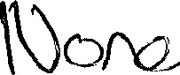 |  | 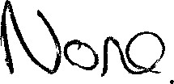
Category of Interest |  | Your Interests |  | Interests of your s ouse/ artner
Corporate tenancies  Any tenancy where (to your knowledge) the landlord is the Isle of Wight Council and the tenant is a body in which you or your spouse or partner, has a beneficial interest.  Please give address or description sufficient to identify the location. |  | 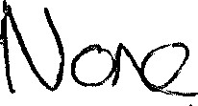 |  | 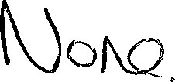
Securities  Any beneficial interest in securities (shares, debentures, debenture stock, loan stock, bonds, units of a collective investment scheme within the Financial Services and Markets Act 2000 and other securities of any description other than money deposited with a building society) of a body where that body (to your knowledge) has a place of business or land in the Isle of Wight; and either  - the total nominal value of the securities exceeds E25,000 or one hundredth of the total issued share capital of that body; or  - if the share capital of that body is of more than one class, the total nominal value of the shares of any one class in which the relevant person has a beneficial interest exceeds one hundredth of the total issued share capital of that class. |  | 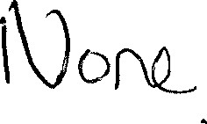 |  | 1k) cro

ADDITIONAL INTERESTS AS AGREED BY CALBOURNE PARISH COUNCIL TO BE INCLUDED IN THE MEMBERS REGISTER OF INTERESTS
Only your interests are required for these; not those of your spouse/partnern
1 . I am a member of or hold a position of general control or management in the following bodies to which I have been appointed or nominated by the authority as its representative:
2. I am a member of or hold a position of general control or management in the following:
- Public authorities or bodies exercising functions of a public nature:
- company, industrial and provident society, charity, or body directed to charitable purposes
(this will include Freemasonry);

\kJONQ
- body whose principal purposes include the influence of public opinion or policy;

- trade union or professional association.
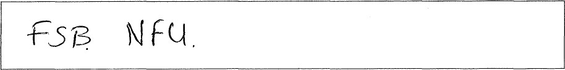
f/ 5/ (2013
Date:
Signed:
RECEIVED:
Date:
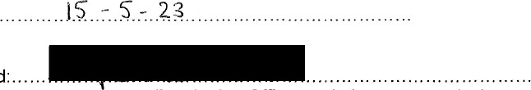
Signed:
(Monitoring Officer or their representative)

