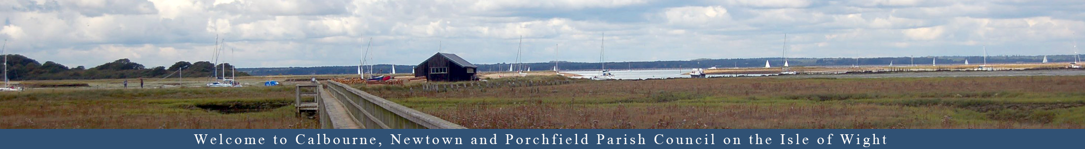

CALBOURNE NEWTOWN AND PORCHFIELD PARISH COUNCIL

NOTICE OF VACANCY FOR A COUNCILLOR FOR THE NEWTOWN WARD Published: 16th May 2026
ARE YOU COMMUNITY MINDED? DO YOU WANT TO BE INVOLVED
IN YOUR COMMUNITY?
Do you live within a three-mile radius of Calbourne, Newtown and Porchfield Parish Boundary?

The Newtown Ward covers Newtown, Porchfield, Marks Corner
and part of Thorness.

A Vacancy has arisen for a Councillor to be co-opted onto our Council.
The Council is asking for nominations to fill the vacancy.
If you are interested and would like to be considered, please put forward your name together with a description of what you have done, what can you offer the Council, what your interest are and why you would like to be considered to become a Parish Councillor.

If you would like to talk about what is the role of a Parish Councillor or want any further information, please phone the Parish Clerk on 852576.

Expressions of interest to be with the Clerk by mid-day on the 30th May 2026 to
Valerie Taylor, Parish Clerk
3 Downside, Ventnor, Isle of Wight PO38 1AL
or by email to calbourneclerk@outlook.com

After which Interviews for the candidates will then be arranged.

DATED this 16th May 2026
Valerie Taylor
(Signed) Valerie Taylor

